신채운/202135789

## STEP 1: understand the problem (requirements analysis)

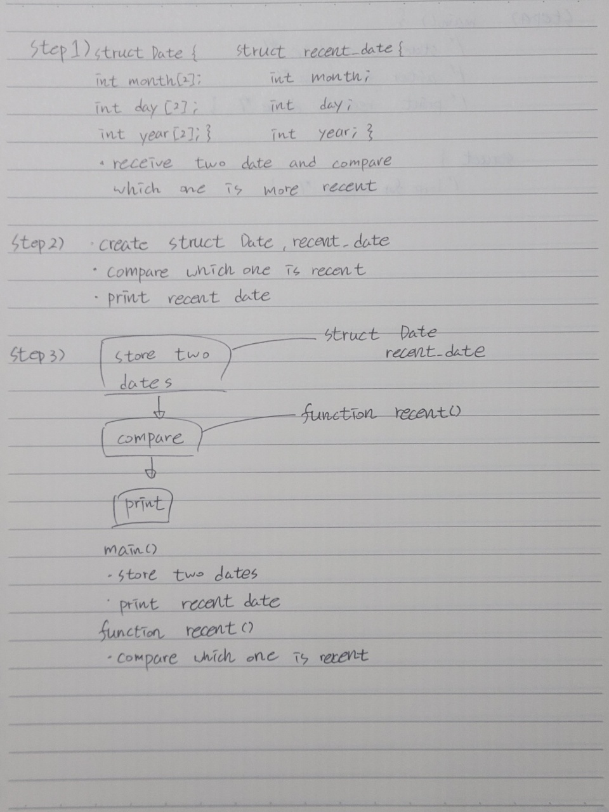

## STEP 2: outline a solution (basic design)



## STEP 3: form a program structure (basic design)



## STEP 4: write a program outline (pseudo code)

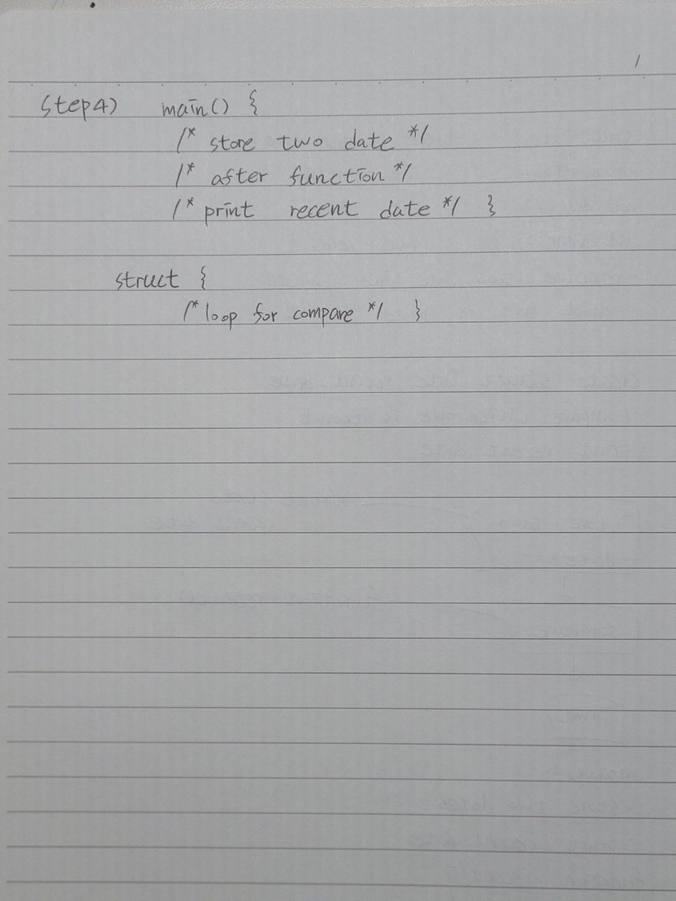

## Source codes & Comment

// 아래 네모 안에 코드를 복사하여 붙일 것

|  |
| --- |
| #include <stdio.h>  /*  file name : Exercise 12.3 4a,4b  author : 202135789 신채운  date : 9 / 30  Course : Problem Solving Methods  description :  Get two different dates  function should return recently date  */  struct Date1 {  int month[2];  int day[2];  int year[2];  };  struct recent_date {  int month;  int day;  int year;  };  struct Date1 Date1;  struct recent_date recent_date;  struct recent_date recent(int[], int[], int[]);  void main() {  printf("The first Date\n"); //store date  printf("Please type month: ");  scanf_s("%d", &Date1.month[0]);  printf("Please type day: ");  scanf_s("%d", &Date1.day[0]);  printf("Please type year: ");  scanf_s("%d", &Date1.year[0]);  printf("The second Date\n");  printf("Please type month: ");  scanf_s("%d", &Date1.month[1]);  printf("Please type day: ");  scanf_s("%d", &Date1.day[1]);  printf("Please type year: ");  scanf_s("%d", &Date1.year[1]);  printf("\nfirst date is %d/%d/%d", Date1.month[0], Date1.day[0], Date1.year[0]);  printf("\nSecond date is %d/%d/%d\n", Date1.month[1], Date1.day[1], Date1.year[1]);  printf("\nRecently date is %d/%d/%d", recent_date.month, recent_date.day, recent_date.year);  }  struct recent_date recent(int month[2], int day[2], int year[2]) {  if (recent_date.year < year[1]) { //loop for compare which one is more recent  recent_date.month = month[0];  recent_date.day = day[0];  recent_date.year = year[0];  }  else if (recent_date.year > year[1]) {  }  else if (recent_date.year = year[1]) {  if (recent_date.month < month[1]) {  recent_date.month = month[0];  recent_date.day = day[0];  recent_date.year = year[0];  }  else if (recent_date.month > month[1]) {  }  else if (recent_date.month = month[1]) {  if (recent_date.day < day[1]) {  recent_date.month = month[0];  recent_date.day = day[0];  recent_date.year = year[0];  }  else if (recent_date.day > day[1]) {  }  else if (recent_date.day = day[1]) {  recent_date.month = month[0];  recent_date.day = day[0];  recent_date.year = year[0];  }  }  }  return recent_date;  } |

## Inspect the program (testing)

// 자가 점검 후 네모 안에 v표시

🗹 Check loop, if else, switch, function.

🗹 Check variable initialization.

🗹 Check pointers.

## Test cases & Output (Screenshots)

|  |  |
| --- | --- |
| # | screenshot |
|  | |